Subgroup F

F.1 — [S13F1] Refactor duplicate discount logic:
Scenario (Agritech E-commerce):
Context:
An agritech marketplace applies seasonal discounts differently for seeds, fertilizers, and tools. Currently, each product type has copy-pasted discount logic, which makes the code hard to maintain.

Your Task:
- Refactor the discount calculation into a single reusable function.
- Ensure that product type determines the discount percentage.
- AI should assist in:
  - Identifying duplicate logic.
  - Suggesting a clean function with parameters.
  - Adding documentation and meaningful names.

Buggy / Duplicate Code (Given):
def seed_discount(price):
return price - price * 0.1

def fert_discount(price):
return price - price * 0.15

def tool_discount(price):
return price - price * 0.05

Data & Edge Cases:
- Discounts: seeds → 10%, fertilizers → 15%, tools → 5%.
- Invalid category should raise ValueError.
- Must handle floating-point prices safely.

AI Assistance Expectation:
- Use AI to generate a refactored single function:
- def apply_discount(price: float, category: str) -> float: ...
- AI should also generate doctest or unit tests for correctness.

Constraints & Notes:
- DRY (Don’t Repeat Yourself) principle must be applied.
- Include type hints in final function signature.
- Add inline docstring with discount table.

Sample Input:
print(apply_discount(100, "fertilizer"))
Sample Output:
85.0

Acceptance Criteria:
- No duplicate discount functions.
- Handles all categories correctly.
- Raises error for unknown category.
- Clean, documented, testable code.
--------------------------------------------------------------------------------------------------------------
Prompt: write a code to generate the discounts of seeds is 10%, fertilizers is 15% and tools is 5% and invalid category should raise ValueError and must handle floating-point prices safely and to generate a refactored single function and def apply_discount(price: float, category: str) -> float:
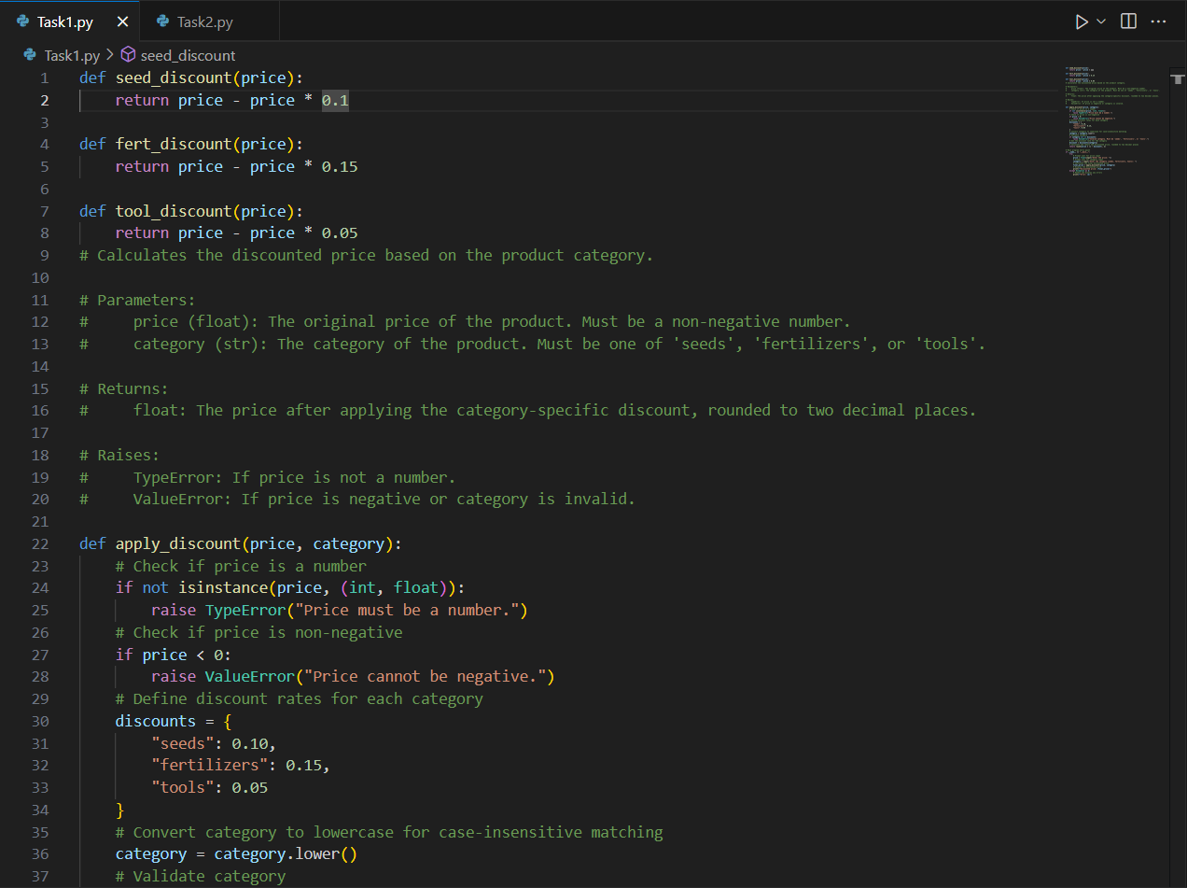

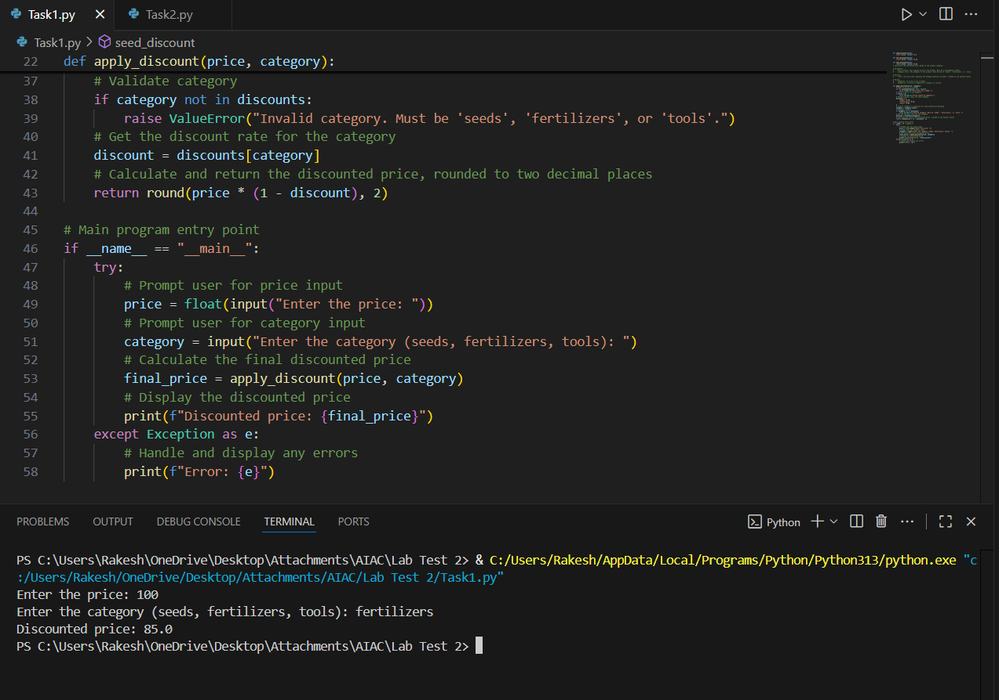

F.2 — [S13F2] Optimize membership checks:
Scenario (agritech):
Context:
A streaming job in agritech checks if IDs are in a large corpus.

Your Task:
Optimize membership checks by converting corpus to a set once, then mapping stream to booleans.

Data & Edge Cases:
corpus=[1,2,3,4,5]; stream=[2,5,9] -> [True, True, False].

AI Assistance Expectation:
Ask AI to suggest complexity improvements and micro-bench ideas.

Constraints & Notes:
Return list[bool] aligned to stream order.
Sample Input
corpus=[1,2,3,4,5], stream=[2,5,9]
Sample Output
[True, True, False]
Acceptance Criteria: Uses set; correct Booleans
------------------------------------------------------------------------------------------
Prompt: write a code to generate return list[bool] aligned to stream order and sample input is corpus=[1,2,3,4,5], stream=[2,5,9] then sample output=[True, True, False]
